Project Design Phase
Problem – Solution Fit Template

Date | 24-09-2026
Team ID | SWTID-2026-6228
Project Name | AI BlogNest API
Maximum Marks | 2 Marks
Problem–Solution Fit Template:
Problem–Solution Fit is the process of identifying a customer's problem and developing a solution that effectively solves it. It helps entrepreneurs, marketers, and innovators understand customer behaviour, improve solution adoption, and create products that meet customer needs.
1. Customer State:
Customer State Fit helps in understanding the target customers, their limitations, and the solutions already available to them.
- Who is the customer?
- What limits the customer from acting when a problem occurs (spending power, network connection, devices, etc.)?
- What solutions are currently available?
- What has the customer tried in the past?
- What are the advantages and disadvantages of existing solutions?
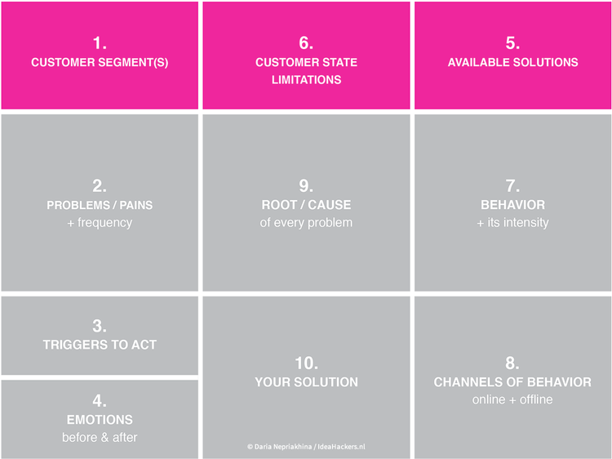
2. Problem and Related Behavior:
This stage identifies the customer's major problems and the behavior associated with them.
- What problem is being solved?
- How often does the problem occur?
- What are the root causes of the problem?
- What actions does the customer currently take to handle the problem?
- How frequently does this behavior occur?

3. Triggers, Emotions and Channels :
This section focuses on customer motivation, emotions, and communication channels.
- What triggers customers to take action?
- What emotions do customers experience before and after the problem is solved?
- Where does this behavior occur online or offline?
- Which communication channels are most effective?
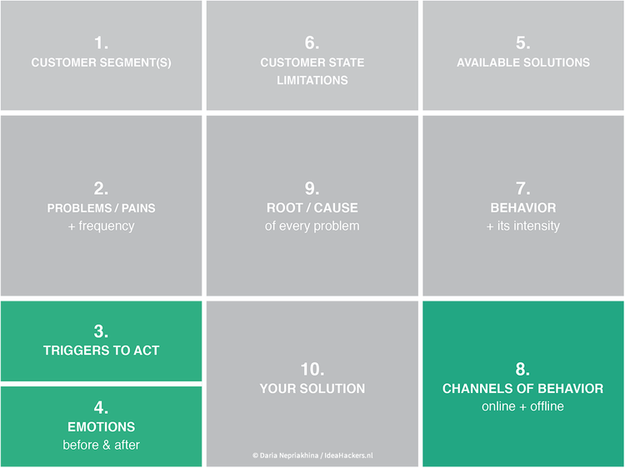

4. Our Solution :
The solution should be designed after understanding customer needs, behavior, and limitations.
- Identify patterns and repeated customer behaviors.
- Develop solutions that fit customer limitations.
- Use ideas from existing successful solutions.
- Ensure the solution is useful, understandable, and accessible.
- Focus on natural customer behavior and triggers.
- Improve solution adoption by solving urgent and frequent problems.

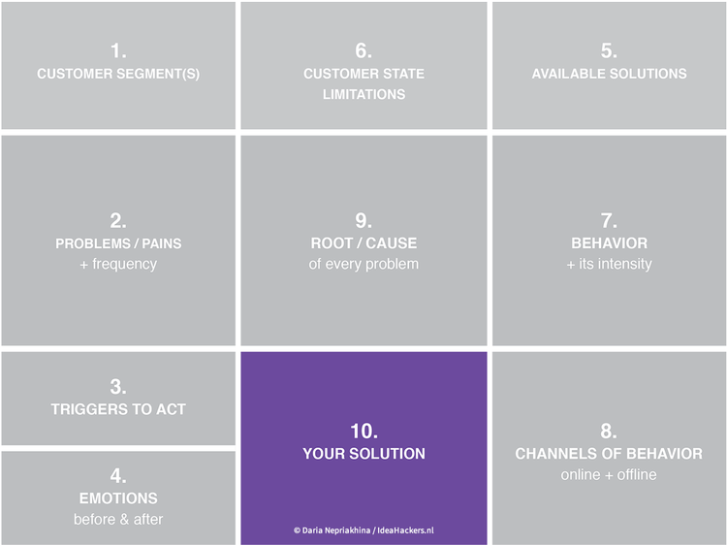
Conclusion :
Problem–Solution Fit helps organizations understand customer needs, identify real problems, and develop effective solutions. By studying customer behavior, emotions, triggers, and limitations, businesses can create solutions that are more useful, accessible, and widely adopted.

